PROJECT REPORT

# 1. Introduction

## 1.1 Project Overview

Now a day’s people are suffering from skin diseases, more than 125 million people suffering from Psoriasis also skin cancer rate is rapidly increasing over the last few decades especially Melanoma is most diversifying skin cancer. If skin diseases are not treated at an earlier stage, then it may lead to complications in the body including spreading of the infection from one individual to the other.

To overcome the above problem, we are building a model which is used for the prevention and early detection of skin cancer, psoriasis. Basically, skin disease diagnosis depends on the different characteristics like colour, shape, texture etc. Here the person can capture the images of skin and then the image will be sent the trained model. The model analyses the image and detect whether the person is having skin disease or not.

## 1.2 Purpose

The diseases are not considered skin diseases, and skin tone is majorly suffered from the ultraviolet rays from the sun. However, dermatologists perform the majority of non-invasive screening tests simply with the naked eye, even though skin illness is a frequent disease for which early detection and classification are essential for patient success and recovery. The characteristic of the skin images is diversified so that it is a challenging job to devise an efficient and robust algorithm for automatic detection of skin disease and its severity. Automatic processing of such images for skin analysis requires quantitative discriminator to differentiate the diseases.

# 2. Literature Survey

## 2.1 Existing problem

A neglected public health problem Skin diseases are among the most common health problems in humans. Considering their significant impact on the individual, the family, the social life of patients, and their heavy economic burden, the public health importance of these diseases is underappreciated.

## 2.2 References

1. J. Kawahara and G. Hamarneh, “Multi-resolution-tract CNN with hybrid pretrained and skin-lesion trained layers,” in International Workshop on Machine Learning in Medical Imaging, pp. 164–171, Springer, New York, NY, USA, 2016.

1. S. Verma, M. A. Razzaque, U. Sangtongdee, C. Arpnikanondt, B. Tassaneetrithep, and A. Hossain, “Digital diagnosis of Hand, Foot, and mouth disease using hybrid deep neural networks,” IEEE Access, vol.

9, pp. 143481–143494, 2021.

1. P. P. Rebouças Filho, S. A. Peixoto, R. V. Medeiros da Nobrega´ et al., “Automatic histologically-closer classification of skin lesions,” Computerized Medical Imaging and Graphics, vol. 68, pp. 40–54, 2018.

## 2.3 Problem Statement Definition

We're trying to find a solution to identify Skin Disease but Developed model is under training because given an image of skin, we can decompose, segment, and classify in a sequential manner which takes to Early detection of skin cancer, psoriasis.

# 3. Ideation and Proposed Solution

## 3.1 Empathy Map Canvas

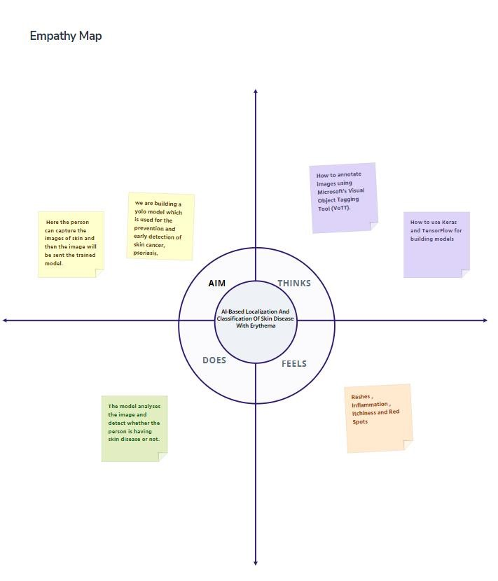

## 3.2 Ideation and Brainstorming

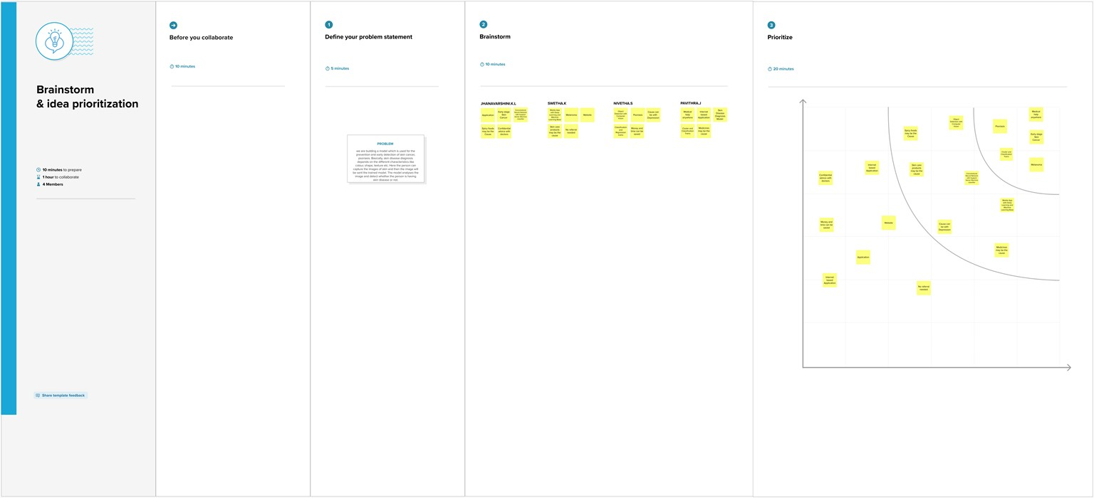

## 3.3 Proposed Solution

Two-phase analysis model. The original image primarily enters a pre-processing stage, where normalization and decomposition occur. Afterwards, the first step is segmentation, where cluster of abnormal skin are segmented and cropped. The second step is classification, where each cluster is classified into its corresponding class. Developed Model is Still under training.

## 3.4 Problem Solution fit

Skin disease can appear in virtually any part of body and there is a lack of data required to form an association between the probability of a skin disease based on the body part. A Solution model used for the prevention and early detection of skin cancer and psoriasis by image analyses to detect whether the person is having skin disease or not. The location of the disease that is present in an image and improved performance by CNN model to focus on particular subsections of the images.

# 4. Requirement Analysis

## 4.1 Functional requirements

Image Acquisition, Pre-processing Steps such as Colour gradient generator on an image , Cropping and isolating region of interest and Thresholding and Clustering on image, Visual feature extraction, System Training YOLO Model for Skin disease classification with deep learning and CNN, Separate access of application for admin, Diagnosis of Skin disease and Data retrieval and Data manipulation.

**4.2 Non-Functional requirements**

Software Quality Attributes, Prediction, Accuracy.

# 5. Project Design

## 5.1 Data Flow Diagram

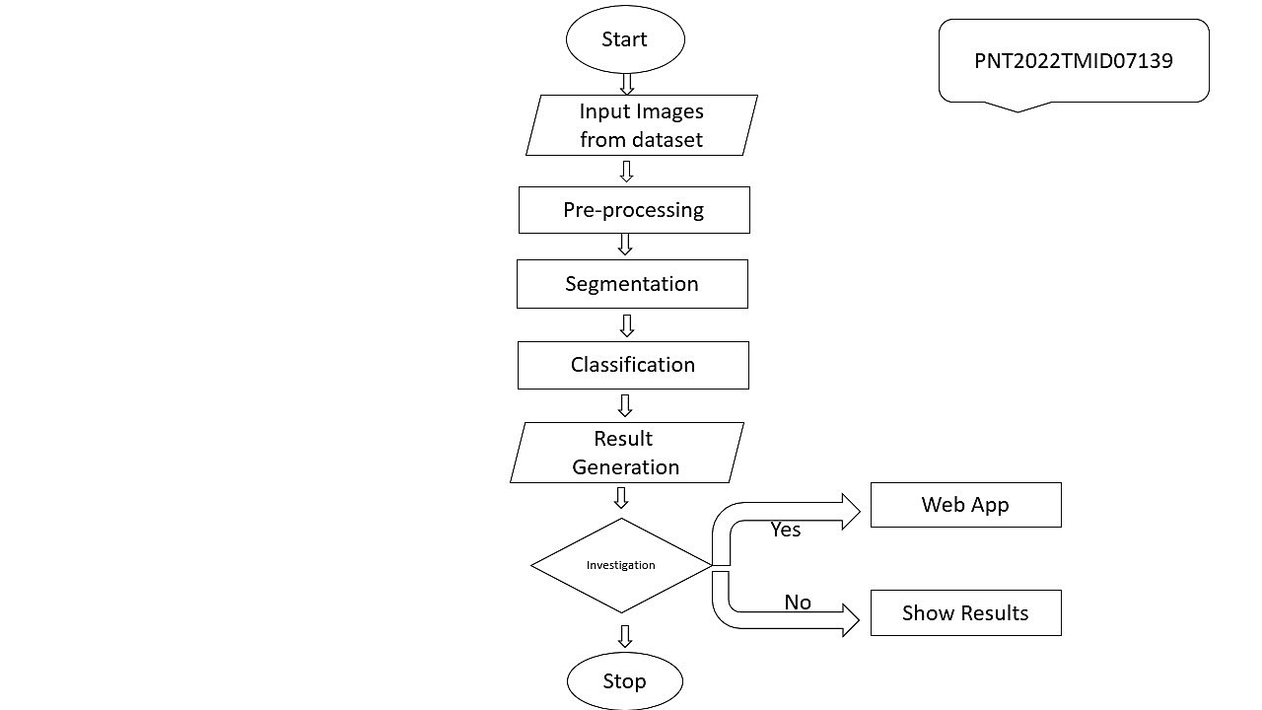

## 5.2 Solution and Technical Architecture

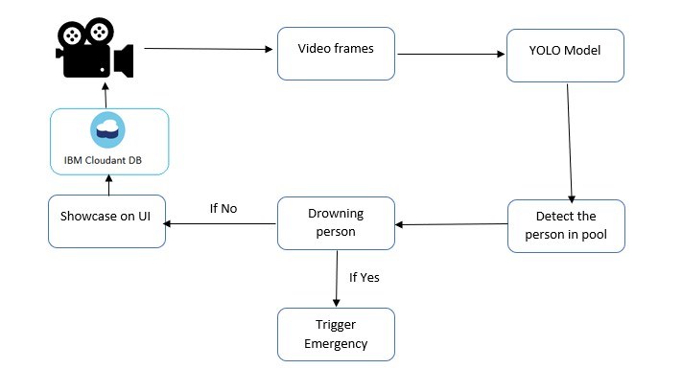

## 5.3 User Stories

|  |  |  |  |  |
| --- | --- | --- | --- | --- |
| **Functional**  **Requirement**  **(Epic)** | **User**  **Story**  **Number** | **User Story / Task** | **Story Points** | **Priority** |
| Prerequisites | USN-1 | Install Python IDE, Python packages,  Microsoft Visual Object Tagging Tool, Yolo Structure | 3 | High |
| Data Collection | USN-2 | Dataset should be collected from google or using a Chrome extension such as Fatkun Batch Downloader | 3 | High |
| Annotate Images | USN-3 | Create A Project in VOTT (Microsoft's Visual  Object Tagging Tool) | 2 | Medium |
| Training YOLO | USN-4 | train our model using YOLO weights | 2 | Medium |
|  | USN-5 | To Download and Convert Pre-Trained  Weights | 3 | High |
|  | USN-6 | To Train YOLOv3 Detector | 3 | High |
| Cloudant DB | USN-7 | Register & Login to IBM Cloud | 3 | High |
|  | USN-8 | Create Service Instant and Credentials | 2 | Medium |
|  | USN-9 | Launch DB and Create database | 3 | High |
| Development Phase | USN-10 | To build a web application | 3 | High |
|  | USN-11 | Building HTML pages with python code | 2 | Medium |
|  | USN-12 | To run the application | 3 | High |
| Testing Phase | USN-13 | As a user login to dashboard | 2 | Medium |
|  | USN-14 | As a user import the images with skin diseases to the software application | 2 | Medium |
|  | USN-15 | YOLO processes the image and give the necessary details | 3 | High |

# 6. Project Planning and Scheduling

## 6.1 Sprint Planning and Estimation

|  |  |  |  |  |  |  |
| --- | --- | --- | --- | --- | --- | --- |
| **Sprint** | **Functional**  **Requirement**  **(Epic)** | **User**  **Story**  **Number** | **User Story / Task** | **Story Points** | **Priority** | **Team Members** |
| Sprint-1 | Prerequisites | USN-1 | Install Python IDE, Python packages, Microsoft Visual  Object Tagging Tool, Yolo  Structure | 3 | High | Jhanavarshini.K.L  Swetha.K  Pavithra.J  Nivetha.S |
| Sprint-1 | Data Collection | USN-2 | Dataset should be collected from google or using a Chrome extension such as Fatkun  Batch Downloader | 3 | High | Jhanavarshini.K.L  Swetha.K  Pavithra.J  Nivetha.S |
| Sprint-1 | Annotate Images | USN-3 | Create A Project in VOTT  (Microsoft's Visual Object  Tagging Tool) | 2 | Medium | Jhanavarshini.K.L  Swetha.K  Pavithra.J  Nivetha.S |
| Sprint-2 | Training YOLO | USN-4 | train our model using YOLO weights | 2 | Medium | Jhanavarshini.K.L  Swetha.K  Pavithra.J  Nivetha.S |
| Sprint-2 |  | USN-5 | To Download and Convert PreTrained Weights | 3 | High | Jhanavarshini.K.L  Swetha.K  Pavithra.J  Nivetha.S |
| Sprint-2 |  | USN-6 | To Train YOLOv3 Detector | 3 | High | Jhanavarshini.K.L  Swetha.K  Pavithra.J  Nivetha.S |
| Sprint-3 | Cloudant DB | USN-7 | Register & Login to IBM Cloud | 3 | High | Jhanavarshini.K.L  Swetha.K  Pavithra.J  Nivetha.S |
| Sprint-3 |  | USN-8 | Create Service Instant and Credentials | 2 | Medium | Jhanavarshini.K.L  Swetha.K  Pavithra.J  Nivetha.S |
| Sprint-3 |  | USN-9 | Launch DB and Create database | 3 | High | Jhanavarshini.K.L  Swetha.K  Pavithra.J  Nivetha.S |
| Sprint-3 | Development Phase | USN-10 | To build a web application | 3 | High | Jhanavarshini.K.L  Swetha.K  Pavithra.J  Nivetha.S |
| Sprint-3 |  | USN-11 | Building HTML pages with python code | 2 | Medium | Jhanavarshini.K.L  Swetha.K  Pavithra.J  Nivetha.S |
| Sprint-3 |  | USN-12 | To run the application | 3 | High | Jhanavarshini.K.L Swetha.K |
| Sprint-4 | Testing Phase | USN-13 | As a user login to dashboard | 2 | Medium | Jhanavarshini.K.L Nivetha.S |
| Sprint-4 |  | USN-14 | As a user import the images with skin diseases to the software application | 2 | Medium | Jhanavarshini.K.L Pavithra.J |
| Sprint-4 |  | USN-15 | YOLO processes the image and give the necessary details | 3 | High | Jhanavarshini.K.L |

## 6.2 Sprint Delivery Schedule

|  |  |  |  |  |
| --- | --- | --- | --- | --- |
| **Sprint** | **Total Story Points** | **Duration** | **Sprint Start Date** | **Sprint End Date (Planned)** |
| Sprint-1 | 20 | 6 Days | 24 Oct 2022 | 29 Oct 2022 |
| Sprint-2 | 20 | 6 Days | 31 Oct 2022 | 05 Nov 2022 |
| Sprint-3 | 20 | 6 Days | 07 Nov 2022 | 12 Nov 2022 |
| Sprint-4 | 20 | 6 Days | 14 Nov 2022 | 19 Nov 2022 |

# 7. Coding and Solutioning

pip3 install tensorflow tensorflow_hub matplotlib seaborn numpy pandas sklearn imblearn

import tensorflow as tf import tensorflow_hub as hub import matplotlib.pyplot as plt import numpy as np import pandas as pd import seaborn as sns

from tensorflow.keras.utils import get_file

from sklearn.metrics import roc_curve, auc, confusion_matrix

from imblearn.metrics import sensitivity_score, specificity_score

import os import glob import zipfile

import random

# to get consistent results after multiple runs

tf.random.set_seed(7) np.random.seed(7)

random.seed(7)

# 0 for benign, 1 for malignant

class_names = ["benign", "malignant"]

## Preparing the Dataset

def download_and_extract_dataset():

# dataset from https://github.com/udacity/dermatologist-ai

# 5.3GB

train_url = "https://s3-us-west-1.amazonaws.com/udacity-dlnfd/datasets/skin-cancer/train.zip"

# 824.5MB

valid_url = "https://s3-us-west-1.amazonaws.com/udacity-dlnfd/datasets/skin-cancer/valid.zip"

# 5.1GB test_url = "https://s3-us-west-1.amazonaws.com/udacity-dlnfd/datasets/skin-cancer/test.zip" for i, download_link in enumerate([valid_url, train_url, test_url]): temp_file = f"temp{i}.zip"

data_dir = get_file(origin=download_link, fname=os.path.join(os.getcwd(), temp_file)) print("Extracting", download_link) with zipfile.ZipFile(data_dir, "r") as z: z.extractall("data") # remove the temp file

os.remove(temp_file)

# comment the below line if you already downloaded the dataset download_and_extract_dataset()

# preparing data

# generate CSV metadata file to read img paths and labels from it def generate_csv(folder, label2int): folder_name = os.path.basename(folder) labels = list(label2int) # generate CSV file df = pd.DataFrame(columns=["filepath", "label"]) i = 0 for label in labels: print("Reading", os.path.join(folder, label, "*")) for filepath in glob.glob(os.path.join(folder, label, "*")):

df.loc[i] = [filepath, label2int[label]] i += 1

output_file = f"{folder_name}.csv" print("Saving", output_file)

df.to_csv(output_file)

# generate CSV files for all data portions, labeling nevus and seborrheic keratosis

# as 0 (benign), and melanoma as 1 (malignant)

# you should replace "data" path to your extracted dataset path # don't replace if you used download_and_extract_dataset() function generate_csv("data/train", {"nevus": 0, "seborrheic_keratosis": 0, "melanoma": 1}) generate_csv("data/valid", {"nevus": 0, "seborrheic_keratosis": 0, "melanoma": 1}) generate_csv("data/test", {"nevus": 0, "seborrheic_keratosis": 0, "melanoma": 1})

# loading data

train_metadata_filename = "train.csv" valid_metadata_filename = "valid.csv" # load CSV files as DataFrames df_train = pd.read_csv(train_metadata_filename) df_valid = pd.read_csv(valid_metadata_filename) n_training_samples = len(df_train) n_validation_samples = len(df_valid) print("Number of training samples:", n_training_samples) print("Number of validation samples:", n_validation_samples) train_ds = tf.data.Dataset.from_tensor_slices((df_train["filepath"], df_train["label"])) valid_ds = tf.data.Dataset.from_tensor_slices((df_valid["filepath"], df_valid["label"]))

**Output:**

## Number of training samples: 2000 Number of validation samples: 150

# preprocess data def decode_img(img):

# convert the compressed string to a 3D uint8 tensor img = tf.image.decode_jpeg(img, channels=3)

# Use `convert_image_dtype` to convert to floats in the [0,1] range. img = tf.image.convert_image_dtype(img, tf.float32) # resize the image to the desired size. return tf.image.resize(img, [299, 299])

def process_path(filepath, label): # load the raw data from the file as a string img = tf.io.read_file(filepath) img = decode_img(img)

return img, label

valid_ds = valid_ds.map(process_path) train_ds = train_ds.map(process_path)

# test_ds = test_ds for image, label in train_ds.take(1): print("Image shape:", image.shape) print("Label:", label.numpy())

Image shape: (299, 299, 3)

Label: 0

# training parameters batch_size = 64 optimizer = "rmsprop" def prepare_for_training(ds, cache=True, batch_size=64, shuffle_buffer_size=1000): if cache: if isinstance(cache, str): ds = ds.cache(cache) else:

ds = ds.cache() # shuffle the dataset

ds = ds.shuffle(buffer_size=shuffle_buffer_size)

# Repeat forever ds = ds.repeat() # split to batches ds = ds.batch(batch_size)

# `prefetch` lets the dataset fetch batches in the background while the model # is training.

ds = ds.prefetch(buffer_size=tf.data.experimental.AUTOTUNE) return ds

valid_ds = prepare_for_training(valid_ds, batch_size=batch_size, cache="valid-cached-data") train_ds = prepare_for_training(train_ds, batch_size=batch_size, cache="train-cached-data") batch = next(iter(valid_ds))

def show_batch(batch): plt.figure(figsize=(12,12)) for n in range(25): ax = plt.subplot(5,5,n+1) plt.imshow(batch[0][n])

plt.title(class_names[batch[1][n].numpy()].title()) plt.axis('off')

show_batch(batch)

Output:

# building

the model

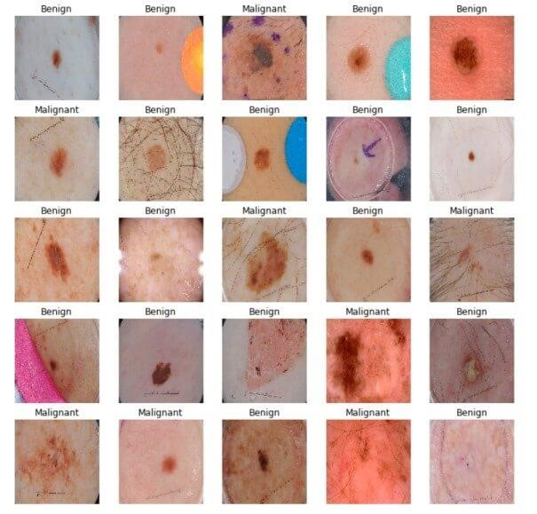

# InceptionV3 model & pre-trained weights

module_url = "https://tfhub.dev/google/tf2-preview/inception_v3/feature_vector/4"

m = tf.keras.Sequential([

hub.KerasLayer(module_url, output_shape=[2048], trainable=False), tf.keras.layers.Dense(1, activation="sigmoid")

])

m.build([None, 299, 299, 3])

m.compile(loss="binary_crossentropy", optimizer=optimizer, metrics=["accuracy"])

m.summary()

Output:

Model: "sequential"

_________________________________________________________________

Layer (type) Output Shape Param #

=================================================================

keras_layer (KerasLayer) multiple 21802784 _________________________________________________________________

dense (Dense) multiple 2049

================================================================= Total params: 21,804,833

Trainable params: 2,049

Non-trainable params: 21,802,784

_________________________________________________________________

### Training the Model

model_name = f"benign-vs-malignant_{batch_size}_{optimizer}"

tensorboard = tf.keras.callbacks.TensorBoard(log_dir=os.path.join("logs", model_name))

# saves model checkpoint whenever we reach better weights

modelcheckpoint = tf.keras.callbacks.ModelCheckpoint(model_name + "_{val_loss:.3f}.h5", save_best_only=True, verbose=1)

history = m.fit(train_ds, validation_data=valid_ds, steps_per_epoch=n_training_samples // batch_size,

validation_steps=n_validation_samples // batch_size, verbose=1, epochs=100, callbacks=[tensorboard, modelcheckpoint])

**Output:**

Train for 31 steps, validate for 2 steps

Epoch 1/100

30/31 [============================>.] - ETA: 9s - loss: 0.4609 - accuracy: 0.7760 Epoch 00001: val_loss improved from inf to 0.49703, saving model to benign-vsmalignant_64_rmsprop_0.497.h5

31/31 [==============================] - 282s 9s/step - loss: 0.4646 - accuracy: 0.7722 - val_loss:

0.4970 - val_accuracy: 0.8125

<..SNIPED..>

Epoch 27/100

30/31 [============================>.] - ETA: 0s - loss: 0.2982 - accuracy: 0.8708 Epoch 00027: val_loss improved from 0.40253 to 0.38991, saving model to benign-vsmalignant_64_rmsprop_0.390.h5

31/31 [==============================] - 21s 691ms/step - loss: 0.3025 - accuracy: 0.8684 - val_loss: 0.3899 - val_accuracy: 0.8359

<..SNIPED..>

Epoch 41/100

30/31 [============================>.] - ETA: 0s - loss: 0.2800 - accuracy: 0.8802

Epoch 00041: val_loss did not improve from 0.38991

31/31 [==============================] - 21s 690ms/step - loss: 0.2829 - accuracy: 0.8790 - val_loss: 0.3948 - val_accuracy: 0.8281

Epoch 42/100

30/31 [============================>.] - ETA: 0s - loss: 0.2680 - accuracy: 0.8859

Epoch 00042: val_loss did not improve from 0.38991

31/31 [==============================] - 21s 693ms/step - loss: 0.2722 - accuracy: 0.8831 - val_loss: 0.4572 - val_accuracy: 0.8047

Model Evaluation:

# evaluation # load testing set

test_metadata_filename = "test.csv"

df_test = pd.read_csv(test_metadata_filename) n_testing_samples = len(df_test) print("Number of testing samples:", n_testing_samples)

test_ds = tf.data.Dataset.from_tensor_slices((df_test["filepath"], df_test["label"])) def prepare_for_testing(ds, cache=True, shuffle_buffer_size=1000): if cache: if isinstance(cache, str): ds = ds.cache(cache)

else:

ds = ds.cache() ds = ds.shuffle(buffer_size=shuffle_buffer_size) return ds

test_ds = test_ds.map(process_path) test_ds = prepare_for_testing(test_ds, cache="test-cached-data")

Number of testing samples: 600

# evaluation # load testing set

test_metadata_filename = "test.csv" df_test = pd.read_csv(test_metadata_filename) n_testing_samples = len(df_test)

print("Number of testing samples:", n_testing_samples) test_ds = tf.data.Dataset.from_tensor_slices((df_test["filepath"], df_test["label"]))

def prepare_for_testing(ds, cache=True, shuffle_buffer_size=1000): if cache:

if isinstance(cache, str): ds = ds.cache(cache)

else:

ds = ds.cache()

ds = ds.shuffle(buffer_size=shuffle_buffer_size) return ds

test_ds = test_ds.map(process_path) test_ds = prepare_for_testing(test_ds, cache="test-cached-data")

# load the weights with the least loss

m.load_weights("benign-vs-malignant_64_rmsprop_0.390.h5")

print("Evaluating the model...")

loss, accuracy = m.evaluate(X_test, y_test, verbose=0)

print("Loss:", loss, " Accuracy:", accuracy)

**Output:**

**Evaluating the model...**

**Loss: 0.4476394319534302 Accuracy: 0.8**

def get_predictions(threshold=None):

"""

Returns predictions for binary classification given `threshold`

For instance, if threshold is 0.3, then it'll output 1 (malignant) for that sample if the probability of 1 is 30% or more (instead of 50%)

"""

y_pred = m.predict(X_test) if not threshold: threshold = 0.5 result = np.zeros((n_testing_samples,)) for i in range(n_testing_samples): # test melanoma probability if y_pred[i][0] >= threshold:

result[i] = 1 # else, it's 0 (benign)

return result

threshold = 0.23

# get predictions with 23% threshold

# which means if the model is 23% sure or more that is malignant,

# it's assigned as malignant, otherwise it's benign y_pred = get_predictions(threshold) def plot_confusion_matrix(y_test, y_pred): cmn = confusion_matrix(y_test, y_pred)

# Normalise

cmn = cmn.astype('float') / cmn.sum(axis=1)[:, np.newaxis]

# print it print(cmn)

fig, ax = plt.subplots(figsize=(10,10)) sns.heatmap(cmn, annot=True, fmt='.2f', xticklabels=[f"pred_{c}" for c in class_names], yticklabels=[f"true_{c}" for c in class_names], cmap="Blues"

)

plt.ylabel('Actual') plt.xlabel('Predicted')

# plot the resulting confusion matrix plt.show()

plot_confusion_matrix(y_test, y_pred)

**Output:**

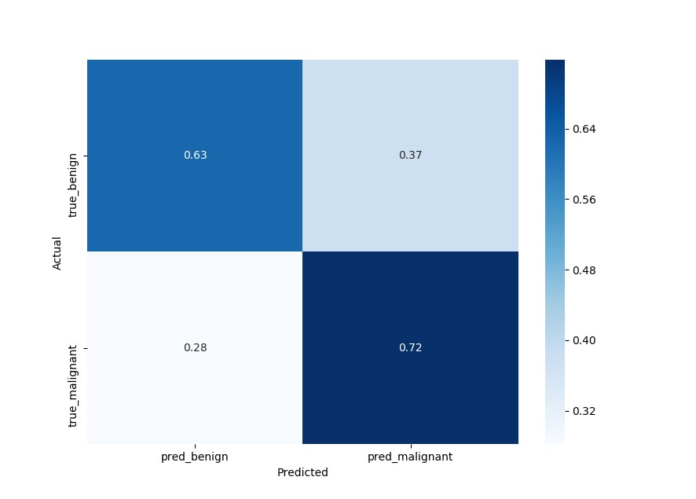

sensitivity = sensitivity_score(y_test, y_pred)

specificity = specificity_score(y_test, y_pred)

print("Melanoma Sensitivity:", sensitivity)

print("Melanoma Specificity:", specificity)

**Output:**

**Melanoma Sensitivity: 0.717948717948718**

**Melanoma Specificity: 0.6252587991718427**

def plot_roc_auc(y_true, y_pred):

"""

This function plots the ROC curves and provides the scores.

"""

# prepare for figure plt.figure()

fpr, tpr, _ = roc_curve(y_true, y_pred)

# obtain ROC AUC roc_auc = auc(fpr, tpr)

# print score

print(f"ROC AUC: {roc_auc:.3f}")

# plot ROC curve

plt.plot(fpr, tpr, color="blue", lw=2,

label='ROC curve (area = {f:.2f})'.format(d=1, f=roc_auc)) plt.xlim([0.0, 1.0]) plt.ylim([0.0, 1.05]) plt.xlabel('False Positive Rate') plt.ylabel('True Positive Rate') plt.title('ROC curves') plt.legend(loc="lower right") plt.show()

plot_roc_auc(y_test, y_pred)

**Output:**

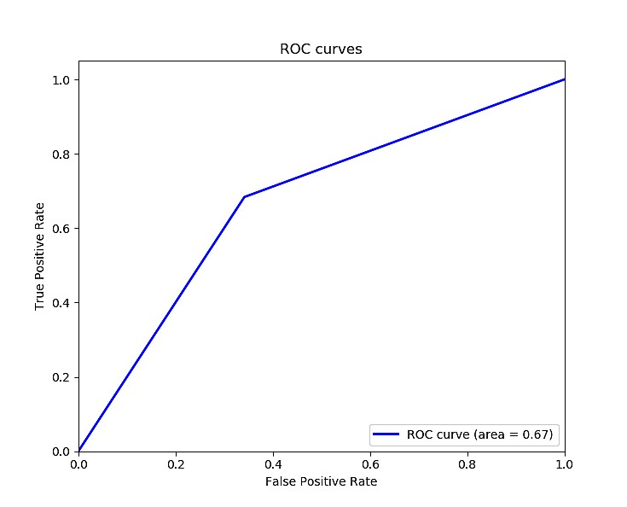

**ROC AUC: 0.671**

# 8. Results

The final results are based on the accuracy results in the form of the melanoma and the non-melanoma skin diseases classifications.

**9**

**.**

**Advantages and**

**Disadvantages**

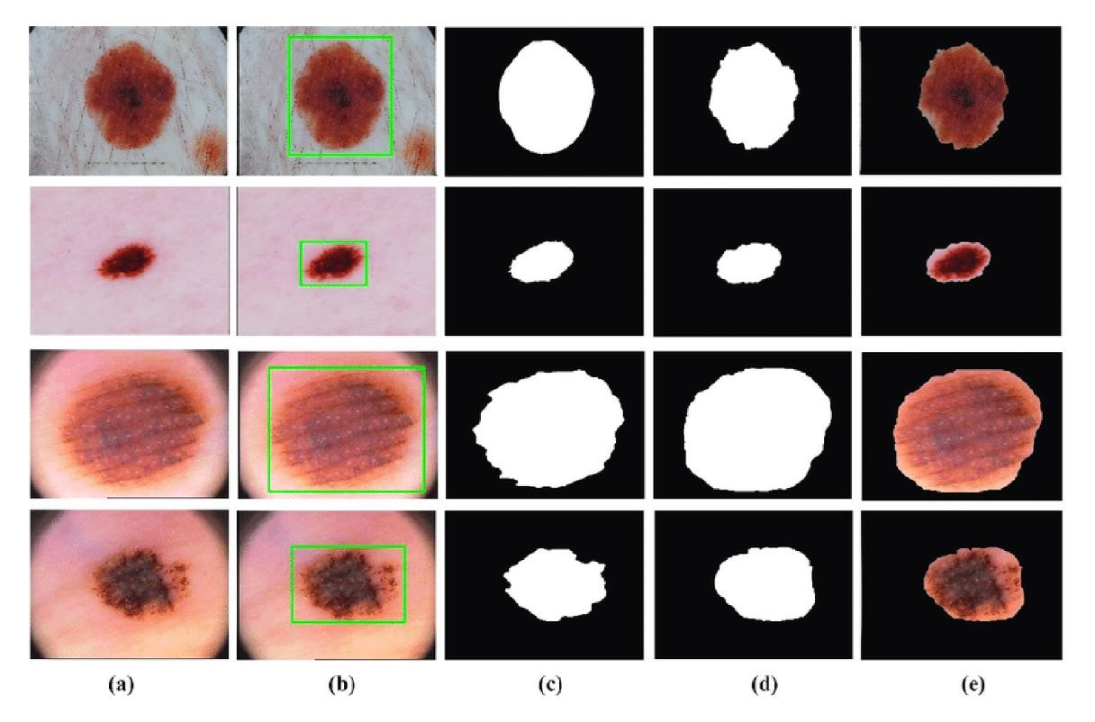

**9.1 Advantages**

Instant Response, improves prediction of Skin Disease, no referral needed, Saves Money and Time, and Confidential Advice.

**9.2 Disadvantages**

Network Connectivity and Accuracy

# 10. Conclusion

We have shown that even without a large dataset and high-quality images, it is possible to achieve sufficient accuracy rates. In addition, we have shown that current state-of-the-art CNN models can outperform models created by previous research, through proper data pre-processing, self-supervised learning, transfer learning, and special CNN architecture techniques. Furthermore, with accurate segmentation, we gain knowledge of the location of the disease, which is useful in the pre-processing of data used in classification, as it allows the CNN model to focus on the area of interest. Lastly, unlike previous studies, our method provides a solution to classify multiple diseases within a single image. With higher quality and a larger quantity of data, it will be viable to use state-of-the-art models to enable the use of CAD in the field of dermatology.

# 11. Future Scope

This implementation of the Structural Co-Occurrence matrices for feature extraction in the skin diseases classification and the pre-processing techniques are handled by using the Median filter, this filter helps to remove the salt and pepper noise in the image processing; thus, it enhances the quality of the images, and normally, the skin diseases are considered as the risk factor in all over the world. Our proposed approach provides 97% of the classification of the accuracy results while another existing model such as FFT + SCM gives 80%, SVM + SCM gives 83%, KNN + SCM gives 85%, and SCM + CNN gives 82%. Future work is dependent on the increased support vector machine’s accuracy in classifying skin illnesses, and SCM is used to manage the feature extraction technique.

# 12. Appendix

GitHub Link:

https://github.com/IBM-EPBL/IBM-Project-38343-1660378786